**Management Notes**

**Lecture#1: (Introduction to project management)**

Advantages of using Project Management Techniques

Better control of financial, physical, and human resources, Improved customer relations, Shorter development times, Lower costs, Higher quality and increased reliability, Higher profit margins, Improved productivity, Better internal coordination, Higher worker morale

Reasons for success

* Average cost of a project has been more than cut in half
* Better tools have been created to monitor and control progress
* Better skilled project managers with better management processes are being used

Project: A temporary endeavor undertaken to create a unique product, service, or result. Projects end when their objectives have been reached or the project has been terminated

Project Attributes:

* has a unique purpose
* has structure, but is temporary
* developed using progressive elaboration
* requires resources
* customer /sponsor -> direction and funding
* involves uncertainty

Project management:isthe application of knowledge, skills, tools and techniques to meet project requirements. Project managers meet scope, time, and cost goals and also facilitate the entire process to meet the needs and expectations of project stakeholders (Tactical goals)

Stakeholders: are the people involved in or affected by project activities (examples: the project sponsor, the project manager, the project team, support staff, customers, users, suppliers and opponents to the project, government citizens affected by the project)

Knowledge areas:describe the key competencies that project managers must develop (project integration, scope, time, cost, quality, human resource, communications, risk, procurement, and stakeholder management)

Project Portfolio Management: Organizations group that manages projects and programs as a portfolio of investments that contribute to the entire enterprise’s success (help make wise investment decisions: select and analyze projects from a strategic perspective) (Strategic goals)

Project managers:work with people involved in a project to meet project goals

Program: group of related projects managed in a coordinated way to obtain benefits and control not available from managing them individually

Program managers:oversee programs; often act as bosses for project managers

Role of Project Manager: plan, schedule, coordinate with people to achieve project goals

Skills of Project Manager:

* People skills, Leadership, Listening
* Integrity, ethical behavior, consistent
* Strong at building trust and teams
* Verbal communication
* Conflict resolution & management
* Critical thinking, problem solving
* Understands & balances priorities

Ethics: set of principles that guide our decision making based on personal values (right, wrong)

Managers are:

* Leaders: long-term goals, big-picture, inspire people to reach goals
* Managers: day-to-day details of meeting specific goals

Large projects: Leadership, relevant prior experience, planning, people skills, verbal communication, and team-building skills

High uncertainty projects: Risk & expectation management, leadership, people, planning skills

Very novel projects: Leadership, people skills, having vision and goals, self-confidence, expectations management, and listening skills

Suggested Skills for Project Management:

* The Project Management Body of Knowledge
* Application area knowledge, standards, and regulations
* Project environment knowledge
* General management knowledge and skills
* Soft skills or human relations skills

Project Management Office (PMO): organizational group responsible for coordinating the project management function throughout an organization (Best practice)

Success: project met scope, time, cost goals, satisfy customer/sponsor, results met objectives

Help Project Succeed: User involvement, Executive support, Clear business objectives, Emotional maturity, Optimizing scope, Agile process, Project management expertise, Skilled resources, Execution, Tools and infrastructure

**Lecture#2: (Approaches to system development)**

Cross-functional innovation team: opens up the organization to new thinking, finds new businesses in white spaces between existing units.

Product innovation team contain people: Strategy, Technology, Engineering, Design, Manufacturing, finance, supply chain, marketing, sales

* Increased Scope = increased time + increased cost
* Tight Time = increased costs + reduced scope
* Tight Budget = increased time + reduced scope.

Project Success: requirements satisfied/exceeded, completed within time & budget, Accepted

Project Failure: Scope creep, poor requirements gathering, unrealistic planning & scheduling, lack of resources

Role of Manager: (Process responsibilities)

* Project issues
* Disseminating project information
* Mitigating project risk
* Quality
* Managing scope
* Metrics
* Managing the overall work plan

Role of Manager: (People responsibilities)

* Implementing standard processes
* Establishing leadership skills
* Setting expectations
* Team building
* Communicator skills

Project must operate in broad organizational environment

PM use systems thinking: integration management

Systems: interacting components working with environment to fulfill purpose

System management: Addresses the business, technological, and organizational issues associated with creating, maintaining, and modifying a system.

Diversity of IT projects: vary in terms of size, complexity, products produced, application area, and resource requirements. Team have diverse backgrounds & skills

IT Project: hardware, software, networks

IS Project: apps that serve informational needs of IS users

System developments Project: bringing out new IS

SD: produce IS. solutions, get IS up & running, change organization by using computers

Stakeholder management: Includes identifying, understanding, and managing relationships with all project stakeholders.

Internal Stakeholders: sponsor, team, support staff, internal customers and managers

External Stakeholders: external customers, competitors, suppliers, government & citizens

Project life cycle: phases-> who works, deliverables, involved, management approve & control

Deliverable: is a product or service provided as part of a project.

Project phases: project should pass all phases successfully to continue

Management reviews (phase exits/ kill points): evaluate progress & compatibility with goals

Project life cycle: same for all projects

Product life cycle: vary according to product

System development life cycle: define -> build/buy -> deploy-> support-> retire -> repeat

Product life cycle: Predictive / Adaptive

Predictive models: the scope is clear, schedule and cost can be predicted

Adaptive models: requirements cannot be clearly expressed

Predictive life cycle models: Waterfall model/ spiral model

Waterfall model:has well-defined, linear stages of systems development and support

Spiral model:software is developed using an iterative or spiral approach

Assumptions of waterfall model:

* Requirements are knowable in advance of implementation
* Requirements have no unresolved implications
* Requirements will not change very much
* The right architecture for implementation is well communicated and understood
* Processes can proceed sequentially
* Requirements are compatible with stakeholders’ expectations

Prototyping model:develop prototypes to clarify user requirements for operational software

Rapid Application Development (RAD): used to produce systems quickly no sacrificing quality

Incremental build model: provides for progressive development of operational software

Prototype: Preliminary working version of info. system for demonstration and evaluation

Prototyping: Process of building experimental system quickly and inexpensively for demonstration and evaluation

Prototyping advantages: Useful in designing end-user interface, useful in testing validity of end user requirements and system acceptance

Prototyping disadvantages: Rapid prototyping can gloss over essential steps in systems development, only limited number of users can be involved

Trends affecting: Globalization, outsourcing, offshoring (countries), virtual teams, agile

Agile software development: collaboration between programming teams & business experts

Waterfall isn’t working: tech., business more complex & req. change rapidly -> use Agile

Agile: move quickly & easily. A method based on iterative and incremental development, in which requirements and solutions evolve through collaboration.

* Individuals & interactions: Over processes and tools
* Working software: Over comprehensive documentation
* Customer collaboration: Over contract negotiation
* Responding to change: Over following a plan

Sprint: one time-boxed iteration of a continuous development cycle 2-4 weeks

Product backlog (prioritized tasks) -> Sprint backlog -> daily scrum meetings -> result -> sprint review -> repeat

Scrum: iterative incremental framework for project management & agile software development

* Scrum Master: maintains the processes
* Product Owner: represents the business (and/or stakeholders)
* Team: a cross-functional people who do analysis, design, implementation, testing, etc.
* Customers, vendors, managers (Chicken roles): people for the software is being built

**Lecture#3: (Integration)**

Process: is a series of actions directed toward a particular result

Project management: number of interlinked processes

Process: Initiating, planning, executing, monitoring, controlling, closing

Integration Processes:

1-Developing the project charter: document with stakeholders formally authorizes a project

2-Developing the project management plan: planning efforts to create a consistent document

3-Directing & managing project: execute project management plan, perform the activities in it.

4-Monitoring and controlling project: overseeing activities to meet the objectives

5-Performing integrated change: identifying, evaluating, and managing changes

6-Closing the project or phase: finalizing all activities to formally close the project or phase.

Strategic planning: determining long-term objectives, predicting future trends, and projecting the need for new products and services

* identify potential projects
* use realistic methods to select which projects to work on
* formalize project initiation by issuing a project charter

SWOT analysis:analyzing **S**trengths, **W**eaknesses, **O**pportunities, and **T**hreats

New Product Development success include the following:

* A product innovation and technology strategy for the business
* Resource commitment and focusing on the right projects
* An effective, flexible and streamlined idea-to-launch process
* The right climate and culture for innovation, true cross-functional teams, and senior management commitment to NPD

Methods for selecting projects include:

Focus on broad organization needs: need for project, available funds, strong will to succeed

Categorizing project: (problem, opportunity, directive), how long & when it is needed, priority

Financial Analysis: Net Present Value (NPV), Return over investment (ROI), Payback analysis

NPV: calculate expected net monetary gain or loss from a project (higher better)

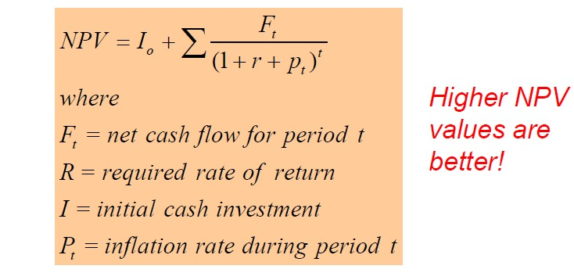

ROI: (total gain - total costs) / total costs * 100 (higher better)

Internal rate of return: calculate discount rate that makes NPV = 0

Payback period: time for cash inflow to offset initial cash outflow

Averaging (Steady cash flow): initial 100 40/year Payback period = 2.5 years

Subtraction (Varying cash flow):

Initial 100 year1 =0 year2= 20 year3= 80 year4 = 90 Payback period = 3 years

Weighted scoring model: weights to criteria, score to each criterion, multiply scores by weights

Integration Processes:

Elements of a project management plan:

* Introduction or overview of the project
* Description of how the project is organized
* Management and technical processes used on the project
* Work to be done, schedule, and budget information

Directing & Managing:

* Perform work in the project management plan
* Most of time and money is spent on execution
* Application area affects execution because products are produced during execution

Coordinating Planning & Execution:

* Project planning and execution are intertwined and inseparable
* Those who will do the work should help to plan the work
* Project managers must solicit input from the team to develop realistic plans

Provide leadership & supportive culture:

* Managers must lead by example
* Organizational culture: Provide guidelines and templates & tracking performance
* Managers need to break rules to meet goals, senior managers support those actions

Capitalizing on Product, Business, and Application Area Knowledge:

IT Manager need to have prior technical experience (small projects: perform tasks/ mentor team) (large projects: understand the business & application area of project)

Project execution tools & techniques:

* Expert judgment: help make many decisions related to project execution
* Meetings: develop relationships have a dialogue to help resolve problems.
* Project management information systems

Monitoring & Controlling Project:

* Important to develop and follow a process to monitor and control changes
* Collecting, measuring, and disseminating performance information
* Baseline is the approved project management plan plus approved changes

Performing Integrated Change Control:

* ensure that changes are beneficial
* Determining that a change has occurred
* Managing actual changes as they occur

Former view of change: no change finish on time & within budget

Problem: stakeholders rarely agreed on scope up-front: time, cost estimates inaccurate

Modern view of change: constant communication & negotiation

Solution: changes are beneficial team should plan for them

Change control system: how & when docs & work can be changed & who can change

Change Control board: group of people to approve/ reject changes, provide guidelines for preparing change requests, evaluate change requests, and manage the implementation of approved changes (stakeholders from the entire organization)

Global issues: rapid changes in tech., incompatible software/hardware

Configuration management ensure descriptions products are correct and complete

Configuration management specialists: identify and document configuration requirements, control changes, record and report changes, and audit the products to verify conformance to requirements

Closing projects/ Phases:

Finalize all activities, transfer the completed /cancelled work to the appropriate people

**Lecture#4: (Scope)**

Scope: work done to create product and the processes used to create them

Project scope management: defining and controlling what is or is not included in a project

Scope processes:

Planning scope: determining how the project’s scope and requirements will be managed

Output: scope management plan and the requirements management plan

Scope management plan:

* How to prepare a detailed project scope statement
* How to create a WBS
* How to maintain and approve the WBS
* How to obtain formal acceptance of the completed project deliverables
* How to control requests for changes to the project scope

Requirement management plan: how project requirements will be analyzed, documented, and managed

Requirement: conditions or capabilities that must be met by the project or present in result to satisfy an agreement

Collecting requirements: defining & documenting features & functions of the products

Collecting requirements: iterative approach, often unclear early in a project

Collecting requirements:

* Interviewing
* Focus groups and facilitated workshops
* Using group creativity and decision-making techniques
* Questionnaires and surveys
* Observation
* Prototyping
* Benchmarking, generating ideas by comparing specific project practices

Requirements traceability matrix (RTM) is a table that lists requirements, various attributes & status of each requirement

Defining scope: reviewing the project charter, requirements documents, and organizational process assets to create a scope statement

Project scope statements: include product scope description, product user acceptance criteria, and detailed information on all project deliverables.

Creating the work-breakdown structure (WBS): subdividing the major project deliverables into smaller, more manageable components

WBS: document that provides the basis for planning and managing project schedules, costs, resources, and changes

Decomposition: subdividing project deliverables into smaller pieces

Work package: is a task at the lowest level of the WBS

Scope baseline includes the approved project scope statement, WBS & WBS dictionary

Approaches to develop WBS:

* Using guidelines
* analogy approach: Review WBSs of similar projects and tailor to your project
* Top-down approach: Start with the largest items & break them down
* Bottom-up approach: Start with the specific tasks and roll them up
* Mind-mapping: Branches radiating out from a core idea to structure thoughts, ideas

WBS dictionary: document that describes detailed information about each WBS item to explain vague items so people can estimate cost & time

Advice to create WBS:

* A unit of work should appear at only one place in the WBS.
* The work content of a WBS item is the sum of the WBS items below it
* A WBS item is the responsibility of 1 person, even if many people are working on it
* The WBS must be consistent with the way in which work is actually going to be performed; it should serve the project team first, and other purposes only if practical
* Project team members should be involved in developing the WBS
* Each WBS item must be documented in a WBS dictionary
* The WBS must be a flexible tool to accommodate inevitable changes

Validating scope: formalizing acceptance of the project deliverables

Scope validation: involves formal acceptance of the completed project deliverables

Acceptance: is often achieved by a customer inspection and then sign-off on key deliverables

Controlling scope: controlling changes to project scope throughout the life of the project

Variance: is the difference between planned and actual performance

Best practices to avoid scope problems:

* Keep the scope realistic.
* Involve users in project scope management.
* Use off-the-shelf hardware and software whenever possible.
* Follow good project management processes

Improve user input:

* Develop a good project selection process
* Have users on the project team in important roles
* Have regular meetings, users sign off on key deliverables presented at meetings
* Deliver something to users and sponsors on a regular basis
* Don’t promise to deliver when you know you can’t
* Co-locate users with developers

Reduce Incomplete and Changing Requirements:

* Requirements management process
* Use techniques such as prototyping, use case modeling
* Write requirements & update them
* Create a requirements management database
* Testing
* Review changes from a systems perspective
* Focus on completion dates to help focus on what’s most important
* Allocate resources specifically for handling change requests/enhancements

**Lecture#5: (Time)**

Time management processes:

* Planning schedule management:

Team uses expert judgment, analytical techniques, and meetings to develop the schedule management plan

* Activity/task: element in (WBS) has expected duration, cost, resource requirements

An activity list table of activities (name, number, brief description)

Activity attributes: info. predecessors, successors, logical relationships, leads and lags, resource requirements, constraints, imposed dates, and assumptions Milestone: event with no duration, several activities, used to monitor goals

* Sequencing activities: relationships between project activities

Reviewing activities and determining dependencies

Dependency/relationship: is the sequencing of project activities or tasks (3 types)

Mandatory dependencies: hard logic (can’t paint walls if they aren’t built)

Discretionary dependencies: defined by the project team (best practice)

External dependencies: relationships between project and non-project activities

Network diagram: display of the logical relationships/sequence between activities

**Arrow diagramming method/activity-on-arrow (AOA)**

Activities are represented by arrows

Nodes or circles are the starting and ending points of activities

Can only show finish-to-start dependencies

**Precedence Diagramming Method (PDM)**

Activities are represented by boxes

Arrows show relationships between activities

Better at showing different types of dependencies

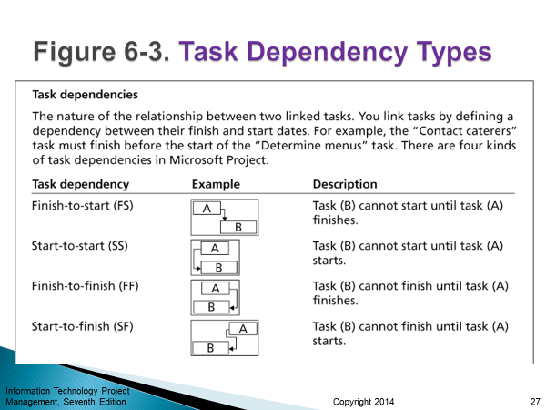

* Estimating activity resources:

Idea of the quantity and type of resources that will be assigned to each activity; Resources are: people, equipment, and materials

Resource breakdown structure: hierarchical structure identifies project’s resources by category and type

* Estimating activity durations: work periods needed to complete 1 activity

Duration: actual amount of time worked on an activity plus elapsed time

Effort: is the number of workdays or work hours required to complete a task

Effort does not normally equal duration

People doing the work should help create estimates, expert should review them

Developing schedule: determine start & end time, basis of monitoring progress

Gantt charts: list activities & their start and finish dates in a calendar format

Milestones: emphasize important events/accomplishments (add to Gantt)

Milestones should be SMART:

* Specific
* Measurable
* Assignable
* Realistic
* Time-framed

Best practice when adding milestones:

1. Define milestones early in the project & add to Gantt chart for visual guidance

2. Keep milestones small and frequent

3. The set of milestones must be all-encompassing (inclusive)

4. Each milestone must be binary, meaning it is either complete or incomplete.

5. Carefully monitor the critical path

CPM is a network diagram technique used to predict total project duration

Critical path: earliest time by which the project can be completed (longest path with least amount of slack & float)

Slack or float: time an activity may be delayed without delaying a succeeding activity or the project finish date

Free slack or free float: time an activity can be delayed without delaying the early start of any immediately following activities

Total slack or total float: time an activity may be delayed from its early start without delaying the planned project finish date

A forward pass: determines the early start and finish dates

A backward pass: determines the late start and finish dates

Three main techniques for shortening schedules (CPM):

* Shortening durations of critical activities/tasks by adding more resources or changing their scope
* Crashing activities by obtaining the greatest amount of schedule compression for the least incremental cost
* Fast tracking activities by doing them in parallel or overlapping them

Critical chain scheduling:

Scheduling to consider limited resources when creating a project schedule and includes buffers to protect the project completion date

Buffer: is additional time to complete a task

Project buffer or additional time added before the project’s due date

Feeding buffers / additional time added before tasks on the critical path

Program Evaluation & Review Technique (PERT): duration high degree of uncertainty

PERT uses probabilistic time estimates: duration estimates based on using optimistic, most likely, and pessimistic estimates of activity durations, or a three-point estimate

PERT weighted avg **=** optimistic time + 4X most likely time + pessimistic time/6

* Developing the schedule: use all previous to create the project schedule
* Controlling the schedule: controlling and managing changes to the project schedule
* Controlling schedule:
  + - Goals are to know the status of the schedule, influence factors that cause schedule changes, determine that the schedule has changed, and manage changes when they occur
    - Tools and techniques include
      * + Progress reports
        + A schedule change control system
        + Project management software, including schedule comparison charts like the tracking Gantt chart
        + Variance analysis, such as analyzing float or slack
        + Performance management
* Working with people: Strong leadership helps succeed more than PERT charts
  + - * + empowerment
        + incentives
        + discipline
        + negotiation

**Lecture#6: (Cost)**

* IT projects have a poor track record for meeting budget goals
* **Cost:** resource sacrificed to achieve an objective (measured in monetary unit: dollars)
* **Profits** are revenues minus expenditures
* **Profit margin** is the ratio of revenues to profits
* **Life cycle costing:** total cost of ownership/development plus support costs, for a project
* **Total cost of ownership:** Purchase, Repairs, Maintenance, Upgrades, Service, Support, Security, training
* **Cash flow analysis**: estimated annual costs & benefits & resulting annual cash flow
* **Project cost management:** ensure project is completed within an approved budget
* **Project cost management processes:**
  + **Planning cost management**: determining the policies, procedures, and documentation used for planning, executing, and controlling project cost.
    - The project team uses expert judgment, analytical techniques, and meetings to develop the cost management plan
  + **Estimating costs:** estimate of costs of resources needed to complete a project
    - Estimates: done at various stages, are more accurate as time progresses

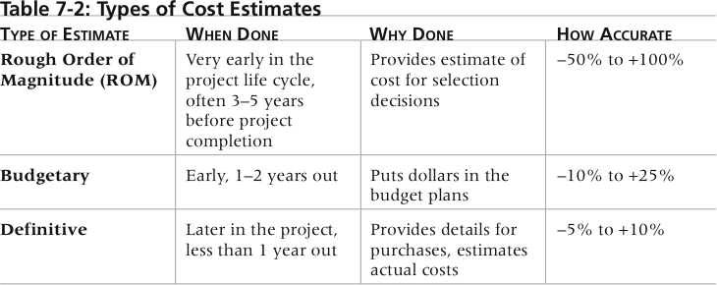

* + - Cost estimation tools & techniques:
      * **Analogous/ top-down estimates:** use the actual cost of a previous
      * **Bottom-up estimates:** involve estimating individual work items/activities and summing them to get a project total
      * **Parametric modeling** uses project characteristics (parameters) in a mathematical model to estimate project costs
    - Problems with IT cost estimates:
      * Estimates are done too quickly
      * People lack estimating experience
      * Human beings are biased toward underestimation
      * Management desires accuracy
  + **Determining the budget:** allocating cost estimate to individual work items to establish a baseline for measuring performance
    - WBS: input to the cost budgeting process since it defines the work items
    - Important goal is to produce a **cost baseline**
      * a time-phased budget manager uses to measure and monitor cost performance
  + **Controlling costs:** controlling changes to the project budget
    - Project cost control includes
    - Monitoring cost performance
    - only appropriate project changes are included in a revised cost baseline
    - Informing stakeholders of authorized changes that will affect costs
* **Types of costs & benefits:**
  + **Tangible costs or benefits:** easily measure in dollars (Increased productivity, reduced waste, reduced defects, reduced rework, reduced cost of operation)
  + **Intangible costs or benefits:** difficult to measure in dollars (Increased customer satisfaction, employee motivation and market share, growth in revenue)
  + **Direct costs are costs:** directly related to products and services of the project(Variable costs) (direct material, direct labor, direct wages)
  + **Indirect costs are costs:** not directly related to products/ services, but are indirectly related to performing the project (Fixed costs) (Rent, office expenses, indirect wages)
  + **Sunk cost:** money that has been spent in the past; when deciding what projects to invest in or continue, you should not include sunk costs
* **Principles of cost management:**
  + **Learning curve theory:** many items are produced repetitively; the unit cost of those items decreases in a regular pattern as more units are produced
  + **Reserves are dollars:** reduce risk
    - **Contingency** reserves allow for future situations that may be partially planned for (sometimes called known unknowns) and are included in the project cost baseline. Reserves allocated at activity level, PM can use reserves alone.
    - **Management** reserves allow for future situations that are unpredictable (sometimes called unknown unknowns). Reserves are allocated at project level, PM must file request to higher management
* **EVM:** performance measurement technique that integrates scope, time, and cost data
* **Given a baseline (original plan plus approved changes), you can determine how well the project is meeting its goals**
* **Earned Value Management terms:**
  + **The planned value (PV):** portion of the approved total cost estimate planned to be spent on an activity during a given period
  + **Actual cost (AC):** total of direct and indirect costs incurred in accomplishing work on an activity during a given period
  + **The earned value (EV):** estimate of the value of the physical work actually completed
  + **EV is based on the original planned costs for the project or activity and the rate at which the team is completing work on the project or activity to date**
  + **Rate of performance (RP)**: ratio of actual work completed to the percentage of work planned to have been completed at any given time during the life of the project or activity

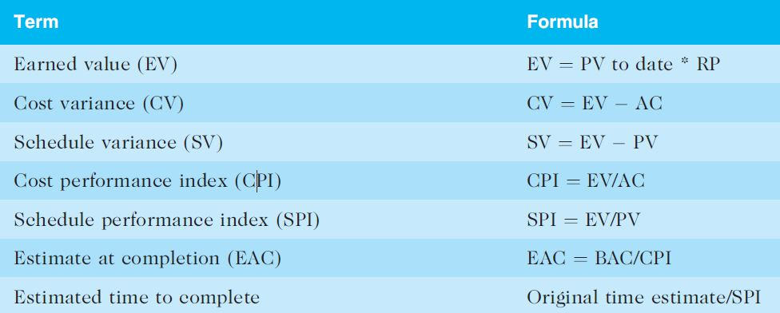

* **Negative** numbers for **cost and schedule variance** indicate **problems**
* **CPI** and **SPI less** than **100%** indicate **problems**
* **Problems mean the project is costing more than planned (over budget) or taking longer than planned (behind schedule)**
* **The CPI can be used to calculate the estimate at completion (EAC)—an estimate of what it will cost to complete the project based on performance to date. The budget at completion (BAC) is the original total budget for the project**

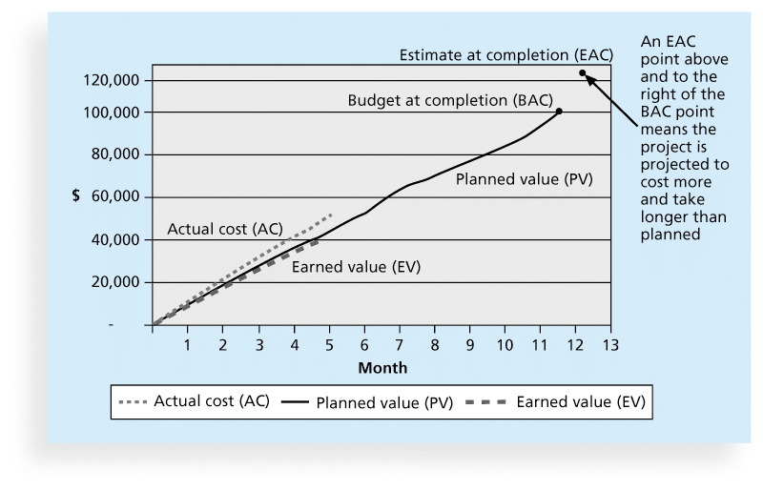

**Lecture#7: (Quality)**

* **Quality:** The International Organization for Standardization (ISO) defines quality as “the degree to which a set of inherent characteristics fulfils requirements”
* **Quality:** **Conformance to requirements**: The project’s processes and products meet written specifications
* **Quality: Fitness for use**: A product can be used as it was intended
* **Project quality management:** project will satisfy the needs for which it was undertaken
* Processes include:
  + **Planning quality management**: Identifying which quality standards are relevant to the project and how to satisfy them; a **metric** is a standard of measurement
    - **Planning quality**: Implies the ability to anticipate situations and prepare actions to bring about the desired outcome
    - Prevent defects by:
      * Selecting proper materials
      * Training and indoctrinating people in quality
      * Planning a process that ensures the appropriate outcome
  + **Performing quality assurance**: Periodically evaluating overall project performance to ensure the project will satisfy the relevant quality standards
    - Prevent defects, proactive process, process-based, manages quality
    - **Quality assurance:** includes all the activities related to satisfying the relevant quality standards for a project
    - Another goal of quality assurance is continuous quality improvement
    - **Benchmarking:** generates ideas for quality improvements by comparing specific project practices or product characteristics to those of other projects or products within or outside the performing organization
    - **Quality audit:** is a structured review of specific quality management activities that help identify lessons learned that could improve performance on current or future projects
  + **Performing quality control**: Monitoring specific project results to ensure that they comply with the relevant quality standards
    - Identify defects, reactive process, product-based, verify quality
* **Functionality** is the degree to which a system performs its intended function
* **Features** are the system’s special characteristics that appeal to users
* **System** **outputs** are the screens and reports the system generates
* **Performance**: how well a product or service performs the customer’s intended use
* **Reliability**: ability of a product/service to perform as expected under normal conditions
* **Maintainability** addresses the ease of performing maintenance on a product
* **Who is responsible for quality?** Manager, ISO & IEEE can help managers

**Lecture#8: (Quality)**

* **Controlling Quality:**
  + **Cause-and-Effect Diagrams (fishbone/Ishikawa):** trace complaints about quality to responsible operation, to find root cause (ask Why 5 times)
  + **Quality Control Charts:** display results of process over time to prevent defects not to detect
    - When a process is in control, any variations in the results of the process are created by random events; processes that are in control do not need to be adjusted
    - When a process is out of control, variations in the results of the process are caused by non-random events; you need to identify the causes of those non-random events and adjust the process to correct or eliminate them
  + **The Seven Run Rule:** if 7 data points in a row are above/below mean are increasing/decreasing process must be examined for non-random problems
  + **Checksheet (tally sheet/ checklist):** collect and analyze data
  + **Scatter diagram:** show if there is a relationship between 2 variables, closer to diagonal -> 2 variables are related
  + **Histograms:** each bar represents an attribute of a problem, height = frequency
  + **Pareto Charts:** histogram to identify and prioritize problem areas, 80-20 rule 80% of problem are due to 20% of causes
  + **Flowcharts:** logic, flow of processes to analyze how problems occur & how processes can be improved
  + **Run charts:** data from variety of sources to see if a pattern emerges, variation of process over time, trend analysis & forecast future outcomes based on history
  + **Six Sigma:** perfection to reach no more than 3.4 defects/ million opportunities
    - 5 phase improvement process DMAIC: loop of improvement
    - **D**efine: Define problem, process, and customer requirements
    - **M**easure: Define measures, then collect, compile, and display data
    - **A**nalyze: Scrutinize process details to find improvement opportunities
    - **I**mprove: Generate solutions and ideas for improving the problem
    - **C**ontrol: Track and verify the stability of the improvements and the predictability of the solution
    - Sigma adopts contrary objectives: reducing errors & doing things faster
    - Philosophy: customer driven, drive out waste, raise quality level, improve financial performance at breakthrough levels
    - Done in teams, PM: team leader, Sponsor: champion
    - Sigma: Standard deviation
    - Standard deviation: how much variance exist in data, finds number of defective units in population
    - **Yield**: number of units handled correctly through the process steps
    - D**efect**: instance of product/service fails to meet customer requirements
    - **69s quality:** measure of quality control=1 fault in 1 million opportunities
  + Testing: should be done at every phase of product life cycle
    - **Unit testing** tests each individual component (often a program) to ensure it is as defect-free as possible
    - **Integration testing** occurs between unit and system testing to test functionally grouped components
    - **System testing** tests the entire system as one entity
    - **User acceptance testing** is an independent test performed by end users prior to accepting the delivered system
* Modern quality management:
  + Requires customer satisfaction
  + Prefers prevention to inspection
  + Recognizes management responsibility for quality
* ISO 9000: 3-part cycle (Plan, Control, Document), provide min req to meet quality certification standards, help organizations reduce cost & improve customer satisfaction
* Suggestions for improving quality for IT projects include:
  + Establish leadership that promotes quality
  + Understand the cost of quality
  + Focus on organizational influences and workplace factors that affect quality
  + Follow maturity models
* Leadership: large percentage of problems are related to management not technical
* Cost of quality: is the cost of conformance plus the cost of nonconformance
  + **Conformance**: delivering products that meet requirements and fitness for use
  + **Cost nonconf.**: take responsibility for failures/not meeting quality expectations
* 5 cost categories:
  + **Prevention cost**: planning & executing error free project/ acceptable error
  + **Appraisal cost**: Cost of evaluating processes and their outputs to ensure quality
  + **Internal failure cost**: Cost to correct defect before customer receive product
  + **External failure cost**: Cost of errors not detected & corrected before delivery to the customer
  + **Measurement and test equipment costs**: Capital cost of equipment used to perform prevention and appraisal activities

**Lecture#9: (Human Resources)**

* **Importance:** People determine the success and failure of organizations and projects
* **Proactive organizations are addressing workforce needs by:**

◦ improving benefits

◦ redefining work hours and incentives

◦ finding future workers

* **Processes include:**

◦ **Planning human resource management:** roles, responsibilities, reporting relationships

◦ **Acquiring the project team:** getting the needed personnel

◦ **Developing the project team:** building individual and group skills

◦ **Managing the project team:** tracking team member performance, motivating team members, providing timely feedback, resolving issues and conflicts, and coordinating changes to help enhance project performance

* **How to deal with people?**

**Motivation Theories:**

* + I**ntrinsic motivation:** do activity for their own enjoyment
  + **Extrinsic motivation:** do something for a reward or to avoid a penalty
  + **Maslow’s Hierarchy of needs:**

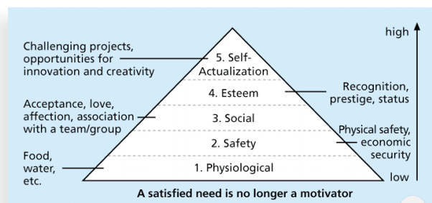

* + **Herzberg Factors:**
    - **Motivational factors:** achievement, recognition, the work itself, responsibility, advancement, and growth, which produce job satisfaction
    - **Hygiene factors:** cause dissatisfaction if not present, but do not motivate workers to do more. Ex: larger salaries, more supervision, and a more attractive work environment
  + **McGregor’s Theory X & Y:**
    - **Theory X:** assumes workers dislike and avoid work, so managers must use coercion, threats and various control schemes to get workers to meet objectives
    - **Theory Y:** assumes individuals consider work as natural as play or rest and enjoy the satisfaction of esteem and self-actualization needs
    - **Theory Z:** motivating workers, emphasizing trust, quality, collective decision making, and cultural values
  + **Thamhain & Wilemon:**
    - **Authority:** legitimate hierarchical right to issue orders
    - **Assignment:** PM's ability to influence a worker's later work assignments
    - **Budget:** PM's ability to authorize others' use of discretionary funds
    - **Promotion:** the ability to improve a worker's position
    - **Money:** the ability to increase a worker's pay and benefits
    - **Penalty:** the project manager's ability to cause punishment
    - **Work challenge:** work to capitalize worker's enjoyment
    - **Expertise:** PM special knowledge that others deem important.
    - **Friendship:** friendly personal relationships between the PM and others
  + **Ways to influence may help/hurt project**
    - **Help:** managers influence with enterprise & work challenge
    - **Hurt:** managers rely on authority money penalty
  + **McClelland’s acquired needs:** needs learned over time, shaped by experience
    - Achievement (nAch): Achievers like challenging projects with achievable goals and lots of feedback
    - Affiliation (nAff): desire harmonious relationships and need to feel accepted by others, so managers should try to create a cooperative work environment for them
    - Power: (nPow): desire either personal power (not good) or institutional power (good for the organization). Provide institutional power seekers with management opportunities
  + **Covey 7 habits:**
    - Be proactive
    - Begin with the end in mind
    - Put first things first
    - Think win/win
    - Seek first to understand then understood
    - Synergize
    - Sharpen the saw
  + **Empathic listening & Rapport:**
    - **Empathic listener:** listen with intention to understand
    - Before communication you must have rapport
    - **Rapport:** relation of harmony, conformity, accord or affinity
    - **Mirroring:** matching of other people behavior to establish rapport
* **Processes: Developing HR plan:**
  + **Organizational chart: define hierarchy**

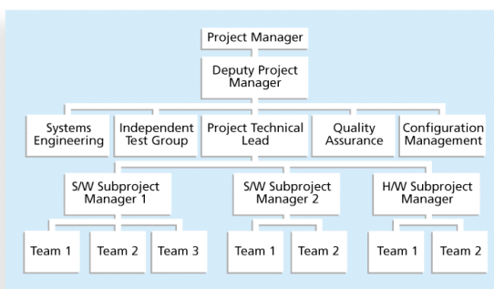

* + **Work definition & assignment process**

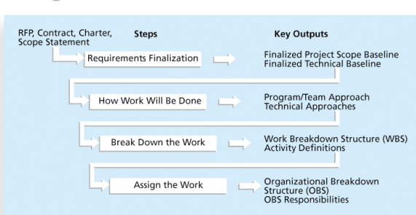

* + **Responsibility Assignment Matrices:** map work item in WBS to responsible

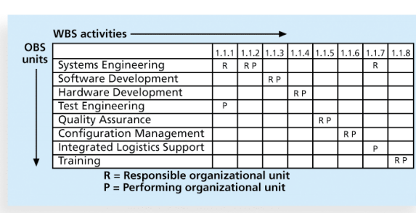

* + **RACI Chart**

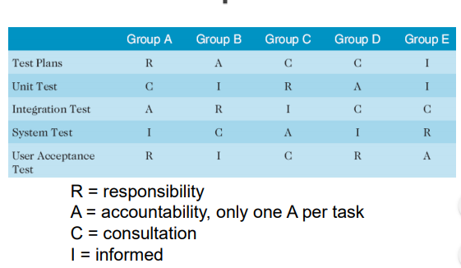

* + **Staffing Management Plans & resource histograms**
    - Staffing management plan: describes when and how people will be added to and taken off the project team
    - Resource histogram: is a column chart that shows the number of resources assigned to a project over time

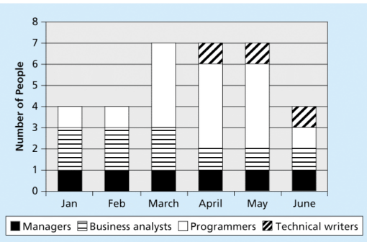

* **Processes: Acquiring Project Team:**
  + Acquiring qualified people for teams (decide on appropriate number & type)
  + Resource assignment: Staffing plans and good hiring procedures are important, as are incentives for recruiting and retention
  + Resource loading: amount of individual resources an existing schedule requires during specific time periods. Helps PM understand demands of project on the organization’s resources and individual people’s schedules
  + Overallocation: more resources than are available are assigned to perform work at a given time
  + Resource leveling: resolve conflicts by delaying tasks, create smoother distribution of resource usage & reduce overallocation (if a task is delayed workers from previous task can work on it, reducing overall num of workers)
  + Benefits of resource leveling:
    - When resources are used on a more constant basis, they require less management
    - It may enable project managers to use a just-intime inventory type of policy for using subcontractors or other expensive resources
    - It results in fewer problems for project personnel and accounting department
    - It often improves morale
* **Processes: Developing Project team**
  + The main goal of team development is to help people work together more effectively to improve project performance
  + **Tuckman model of team development:**
  + Stage1: Forming: Members start interacting (excitement, fear, uncertainty)
  + Stage2: Storming: Conflicts due to personal agendas
  + Stage3: Norming: resolve conflicts, constructive criticisms, work as 1 unit
  + Stage4: Performing: Confidence grows, work towards goal
  + Stage5: Adjourning: members share feeling of loss/relief depending on output
  + **Training:** help people understand themselves, others, how to work together
  + **Team building activities:** physical challenges,psycho. preference indicator tools
  + **MBTI indicator:** state personality, preferences, team understand each other
    - Extrovert/Introvert (E/I)
    - Sensation/Intuition (S/N)
    - Thinking/Feeling (T/F)
    - Judgment/Perception (J/P)
    - IT People not extroverted/sensing
  + Social Styles profile: opposite corners don’t get along well

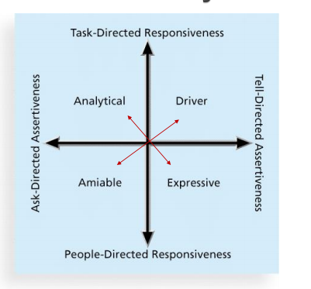

* + DISC Profiles: opposite quadrants have problems understanding each other

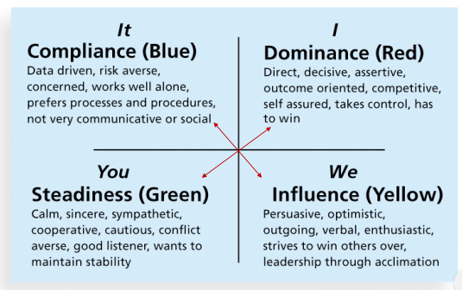

* + Reward & Recognition system:
    - Team reward -> promote teamwork
    - Allow time for team to help each other
* **Processes: Managing Project team**
  + **Tools:** Observation, conversation, appraise performance, interpersonal skills, conflict management
  + **Conflict handling modes:**
    - Confrontation: Directly face a conflict using a problem-solving approach
    - Compromise: Use a give-and-take approach
    - Smoothing: De-emphasize areas of difference and emphasize areas of agreement
    - Forcing: The win-lose approach
    - Withdrawal: Retreat or withdraw from an actual or potential disagreement
    - Collaborating: Decision makers incorporate different viewpoints and insights to develop consensus and commitment

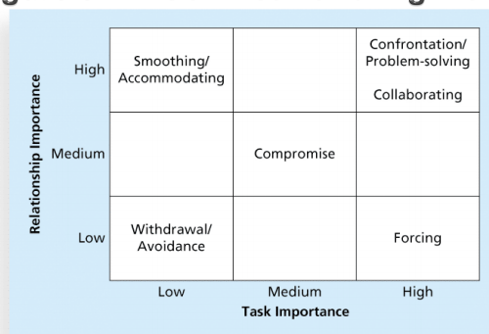

* + **Conflict can be good:** produce new ideas, better alternatives, motivation to work harder & more collaboratively (task conflicts are good, emotional conflicts are bad)
  + **5 dysfunctions of a team:**
    - Absence of trust
    - Fear of conflict
    - Lack of commitment
    - Avoidance of accountability
    - Inattention to results
  + General advice in teams:
    - Be patient and kind with your team
    - Fix the problem instead of blaming people
    - Establish regular, effective meetings
    - Allow time for teams to go through the basic team-building stages
    - Limit the size of work teams to 3 to 7 members
    - Plan some social activities to help project team members and other stakeholders get to know each other better
    - Stress team identity
    - Nurture team members and encourage them to help each other
    - Take additional actions to work with virtual team members
  + Project managers must
    - Treat people with consideration and respect
    - Understand what motivates them
    - Communicate carefully with them
  + Focus on your goal of enabling project team members to deliver their best work

**Lecture#10: (Communication)**

Communication management processes:

* **Planning comm. Manag.:** determine communication needs of stakeholders. **Plan contents:**
  + Stakeholder communications requirements
  + Information to be communicated, including format, content, and level of detail
  + Who will receive the information and who will produce it?
  + Suggested methods or technologies for conveying the information
  + Frequency of communication
  + Escalation procedures for resolving issues
  + Revision procedures for updating the communications management plan
  + A glossary of common terminology
* **Managing comm.:** create, distribute, store, etc. comm. based on comm. plan
  + Get info to right people at right time
  + **Interactive communication:** 2 or more people interact to exchange information via meetings, phone calls, or video conferencing. Most effective way to ensure common understanding
  + **Push communication:** Information is sent or pushed to recipients without their request via reports, e-mails, faxes, voice mails, and other means. Ensures that the information is distributed, but does not ensure that it was received or understood
  + **Pull communication:** Information is sent to recipients at their request via Web sites, bulletin boards, e-learning, knowledge repositories like blogs, and other means
* **Control comm.:** monitor & control comm. to meet stakeholder comm. needs
  + **Report performance:** inform stakeholders about resources used to reach objectives
  + Status reports: where the project stands at a specific point in time
  + Progress reports: what was accomplished during a certain period of time
  + Forecasts: predict future project status & progress based on past info. & trends
  + Lessons learned reports: managers combine all to form project summary report
  + Project archives: accurate history of project
  + Project website
* **Understanding group vs. individual comm. needs:** 9 women can’t produce baby in 1 month
* **Face-to-face comm. is important:** tone, body language
* **Personal preference:** introverts-> private comm., extroverts-> discuss in public, intuitive-> big picture, sensing-> step by step, thinkers->logic behind decisions, feeling-> how something affect them personally, judging-> deadlines, perceiving-> help to follow plans
* **Distribute info.** **in effective & timely manner:** don’t bury imp info good/bad
* **Receiver doesn’t interpret msg as intended:** diff working hrs., language, diff cultures
* **Number of comm.** **channels:** n(n-1)/2
* **Suggestions to improve comm.**:
  + Develop better communication skills
  + Run effective meetings (if a meeting can be avoided, purpose & outcome of meeting, who attends, handouts & visuals, run professional, ground rules, relations)
  + Use e-mail and other technologies effectively
  + Use templates for project communications (people can be afraid to ask-> template)

**Lecture#11: (Risk)**

**Project risk management:** identify, analyze, respond to risks to meet project objectives

Risk: possibility of loss/injury

Negative risk: understand potential problems & how they might affect project

Negative risk management: insurance/investment

Positive risk: result of good thing (opportunity)

Project risk: uncertainty +ve/-ve

Goal of project risk management: minimize -ve & maximize +ve

Widen scope of risk manag: encompass strategic, tactical, +ve, -ve risks (Integrated risk manag)

Risk utility/tolerance: satisfaction from a potential payoff

Risk seeking -> high tolerance

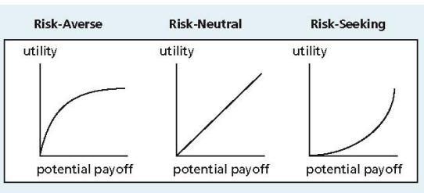

Categories of risk: Market risk, Financial risk, Technology risk, People risk, Structure/process risk

Processes:

Planning risk management: how to approach & plan risk management activities for the project

* risk manag plan: documents the procedures for managing risk throughout a project
* Plan contains: Methodology, Roles and responsibilities, Budget and schedule, Risk categories, Risk probability and impact, Revised stakeholders’ tolerances, Tracking, Risk documentation
* Contingency plan: actions team will take if identified risk event occurs
* Fallback plans: for risks that have a high impact on meeting project objectives, and are put into effect if attempts to reduce the risk are not effective
* Contingency reserves/allowances: provisions held by project sponsor/organization to reduce the risk of cost or schedule overruns to an acceptable level; management reserves are funds held for unknown risks
* Risk breakdown struct: similar to WBS but for risks, hierarchy of potential risks

Identifying risks: which risks are likely to affect a project & document the characteristics of each

* Brainstorming: experienced facilitator to run session
* The Delphi Technique: get consensus from panel anonymously
* Interviewing: interview people with similar projects
* SWOT analysis
* Risk register: document that contains the results of various risk management processes
* Risk event: uncertain events that can destruct/enhance
* 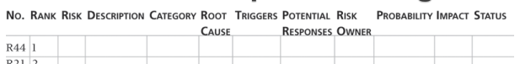

Performing qualitative risk analysis: Prioritizing risks based on their probability & impact

* Probability/impact matrix: probability risk occurring vs. impact of the risk occurring

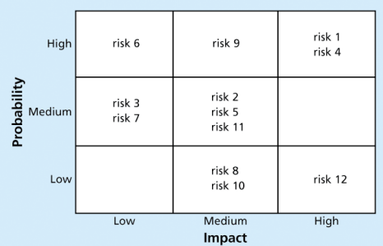

* The Top Ten Risk Item Tracking: periodic review of top 10 risk items
* Watchlist: low probability risks
* Expert judgment

Performing quantitative risk analysis: Numerically estimating the effects of risks on objectives

* Decision tree analysis:

Expected monetary value (EMV)= risk probability* risk event’s monetary value

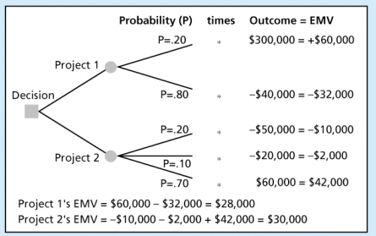

* Simulation: Monte Carlo: optimistic (low percent), most likely, pessimistic (high percent)

Provides early identification of how likely meet project milestones and deadlines.

Can be used to create a more realistic budget and schedule.

Predicts the likelihood of schedule and cost overruns.

Quantifies risks to assess impacts better.

Provides objective data for decision making. of the model’s results

* Sensitivity analysis: effect of changing 1 or more variables on outcome

Planning risk responses: enhance opportunities and reduce threats to meeting project objectives

* Risk avoidance
* Risk acceptance
* Risk transference
* Risk mitigation / reduction
* For +ve risks: Risk enhancement, Risk exploitation, Risk sharing, Risk acceptance
* Residual risks: remain after all of the response strategies have been implemented
* Secondary risks: direct result of implementing a risk response

Controlling risk: Monitoring identified and residual risks, identifying new risks, carrying out risk

response plans, and evaluating the effectiveness of risk strategies throughout life of the project

* Workarounds: are unplanned responses to risk events that must be done when there are no contingency plans

Results of good Project risk management: goes unnoticed, managers make it seem easy

**Lecture#12: (Procurement)**

Procurement: means acquiring goods and/or services from an outside source

People continue to debate whether offshore outsourcing helps their own country or not

Why outsource?

* To access skills and technologies
* To reduce both fixed and recurrent costs
* To allow the client organization to focus on its core business
* To provide flexibility
* To increase accountability

Processes include:

* Planning procurement management: what to procure and when and how

Tools for planning: Expert judgement, Market research: choose suppliers, make/buy

* Conducting procurements: Obtaining seller responses, selecting sellers, award contracts

◦ Approaching the preferred vendor

◦ Approaching several potential vendors

◦ Advertising to anyone interested

Bidders’ conference

Seller selection: sellers prepare best & final offer BAFO

* Controlling procurements: Managing relationships with sellers, monitoring contract performance, and making changes as needed

Hire legal professionals for contracts

Watch for constructive changes that are said & have same effect as written changes

* Closing procurements: Completing and settling each contract or agreement, including resolving of any open items

Contract: mutually binding agreement obligate seller to deliver products & buyer to pay

Types of contracts: (a contract can contain 1 or more type)

* Fixed price or lump sum contracts: fixed total price for a well-defined product or service
* Cost reimbursable contracts: Involve payment to the seller for direct and indirect costs
* Time and material contracts: Hybrid fixed & cost, used by consultants
* Unit price contracts: buyer to pay the seller a predetermined amount per unit of service

Contract clause: consider issues unique to project (termination: allow buyer/seller to terminate)

Contract statement of work (SOW): description of work required for procurement, scope statement, Contract SOW, gives bidders understanding of buyers’ expectations

Request for proposal: doc prepared by seller for diff approaches to meet buyers needs

Requests for quotes: document quotes/bids from suppliers

Bid: doc prepared by seller to price items defined by buyer

**Lecture#13: (Stakeholder)**

Purpose: identify all people/organizations affected by a project, to analyze stakeholder expectations, and to effectively engage stakeholders

Additional stakeholders:

◦ Program director ◦ Project manager’s family ◦ Labor unions ◦ Potential customers

Stakeholder Register: basic info. identification, assessment, classification (internal/external)

Processes include:

◦ Identify stakeholders

◦ Plan stakeholder management

◦ Manage stakeholder engagement

◦ Control stakeholder engagement